Using Microsoft Visual C++ Express

To fully utilize the Visual C++ environment, one must create a project. A project includes a set of source files, with related metadata. To run our programs we will use the Windows Console Application Template (C++).

The Windows Console Application template adds the necessary items needed to create a console application. Console applications are typically designed without a graphical user interface and compiled into stand-alone executable files.

To create a Windows Console Application, follow the steps below:
- On the File menu, click New, and then click Project. The New Project dialog box appears.

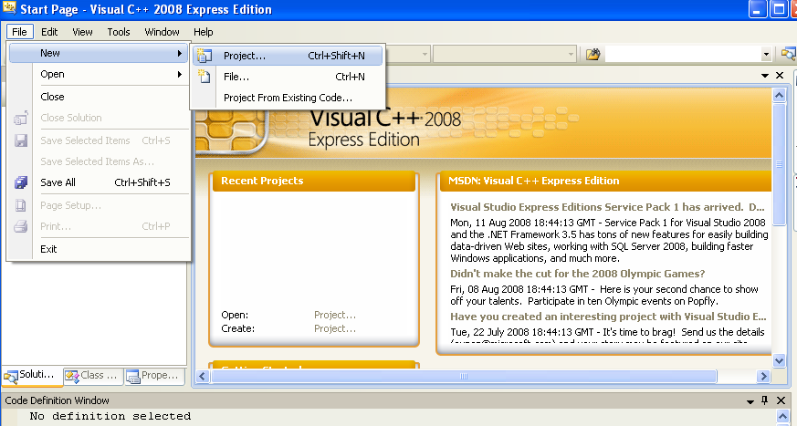

- Make sure that the Visual C++ Projects or Win32 node is selected in the Project Types pane.

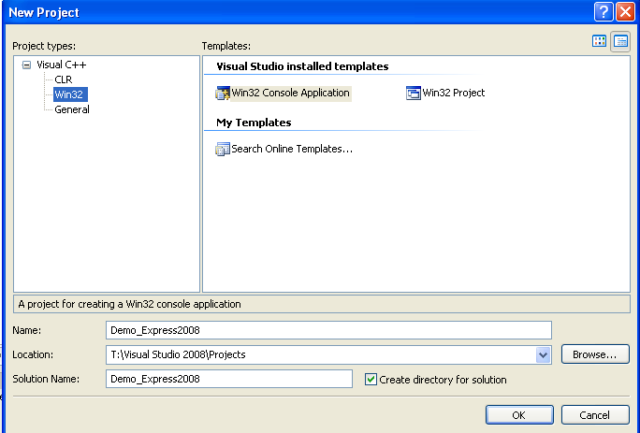

- In the Templates pane, select the WIN32 Console Application project template.
- In the Name box, enter a unique name for your application and make sure the files will be stored in the location you would like them.
- Click OK.

The Win32 Application Wizard starts.

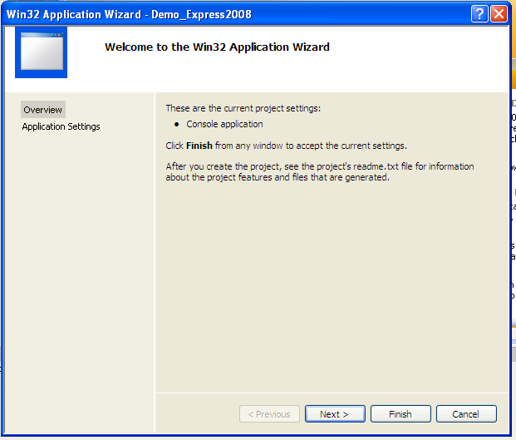

Click the Next> button.

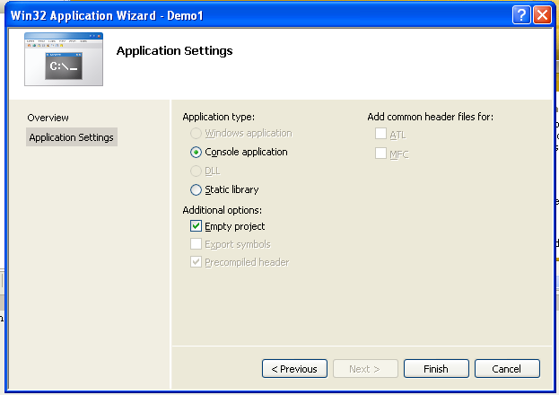

Make sure the Empty project check box is selected and click Finish.

The following screen will display:

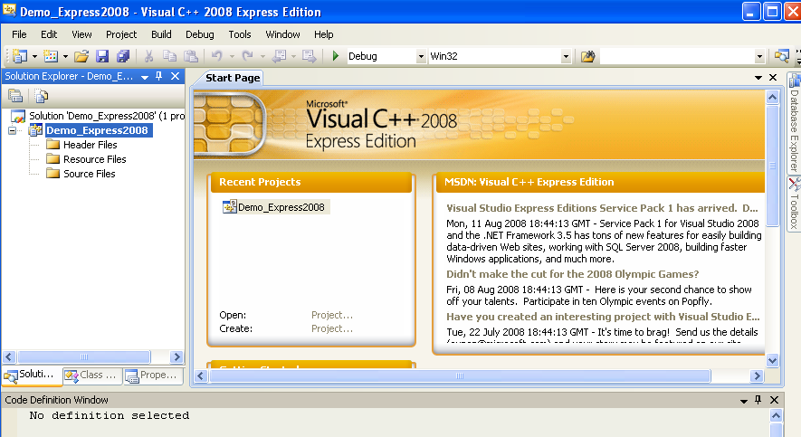

Note that the Solution Explorer pane (on the left side of the window) contains header, resource and source files – each within their own folder.

If when opening a project, the Solution Explorer is not visible click on View and click on Solution Explorer.

To create the source code,
- Add a source file by right-clicking on the Source Folder in the Solution Explorer.
- Select Add/New Item

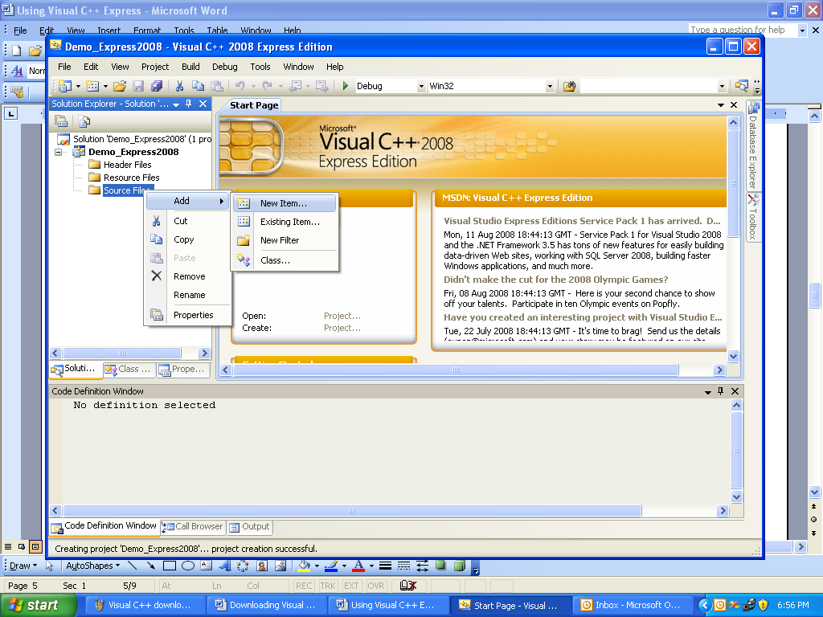

- Make sure that the Code note is selected and indicate C++ File in the Visual Studio Installed Template area. Enter a Program name. Click Add.

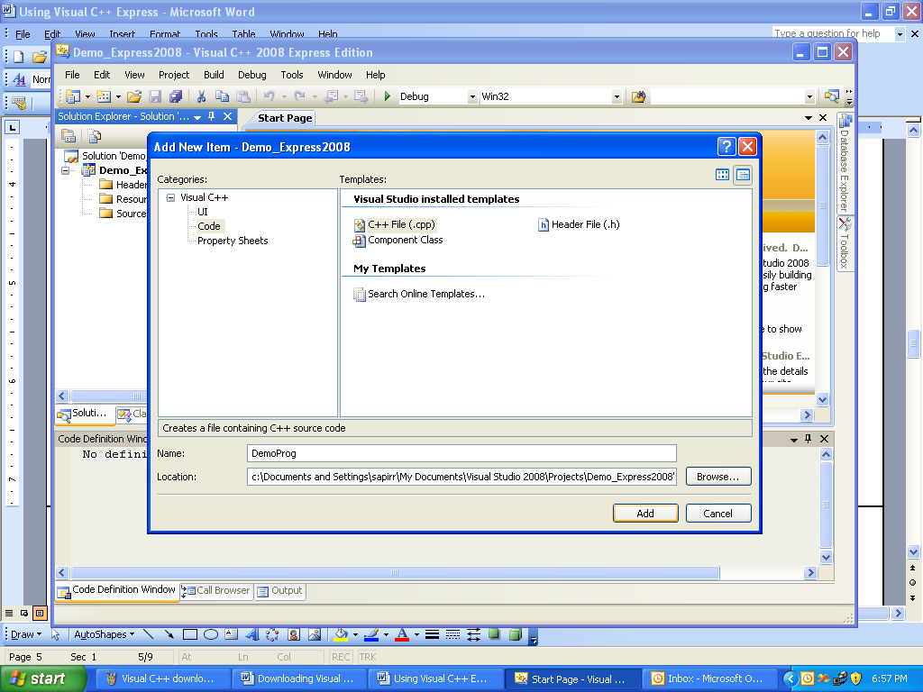

- In the new tab created for your C++ code, type in your program.

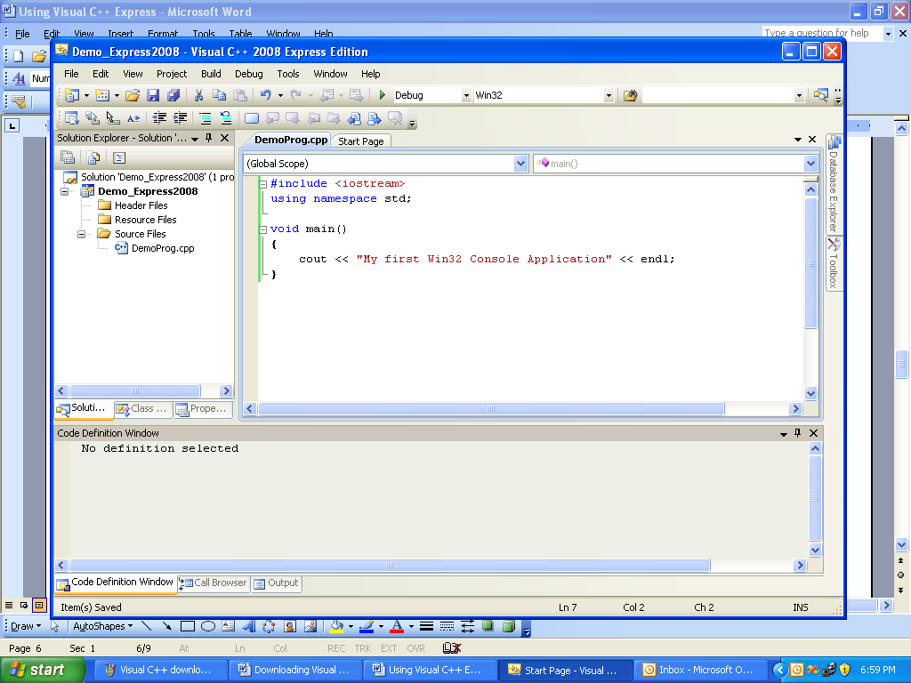

- Save your program.

- To run the program, the solution file needs to be built. You can build the solution by using the Build Solution from the Build pull-down menu, or by specifying Start Without Debugging from the Debug menu, or by simply typing CTRL/F5.
- Once you run the program you will want to save the output to a file. Click on the c:\ icon. A menu will drop down and you will be able to select the output.
Click on Edit and select Mark. Drag your cursor and highlight the output you wish to copy. Click on the c:\ icon again and once again click on Edit. Click on Copy. A copy of the output is now available to be pasted into a text file.

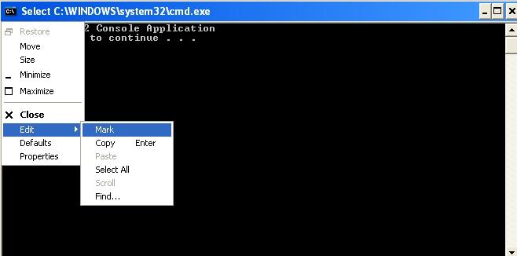

- In Visual C++ Express, click on File, New and then File and click on Text File. Click on Open and a window will open where you can save your output in a text file.
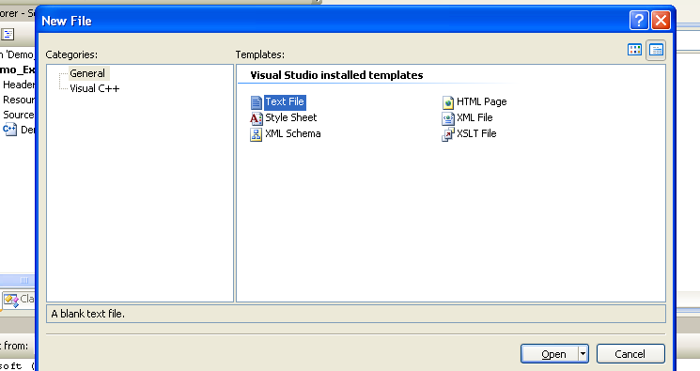

- You can now copy the output into the text window. Save this file and submit it as documentation.

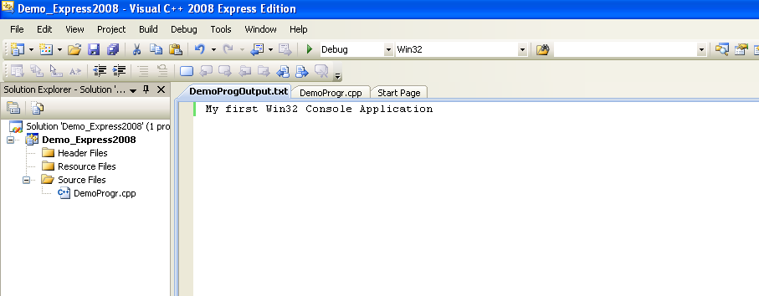

- As part of your documentation please also attach your .cpp file only. The .cpp file for this project is located in the subfolder with the project name:
